Dissertation Submitted to Zhejiang Gongshang University for Master of Business Administration
(Times New Roman三号加粗，居中)

Title (空一行开始写学位论文英文题目，三号Times New Roman，居中)

Author： （Times New Roman小三号加粗）
Major： Master of Business Administration
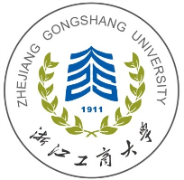
Supervisor：

June. 2020
School of MBA
Zhejiang Gongshang University
Hangzhou, 310018, P. R. China
（以上Times New Roman小三号加粗，居中）

